Question 1.

Do the students performing good in Matric/O-level exams have a better chance of getting admission in NUCES?

* Performing Good in Matric/O-level exam greater than 85 percent marks.
* Error student Matric obtained marks and intermediate obtained marks are the same.

Yes,

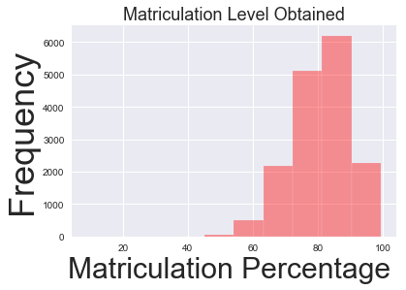

* Most of the students apply the NUCES entry test the matriculation marks greater than 70 percent marks.

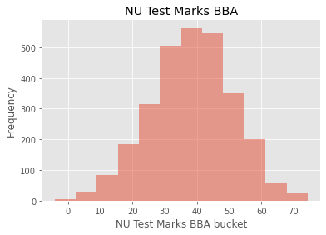

* Most of the student NU Test scores BBA 30-60.

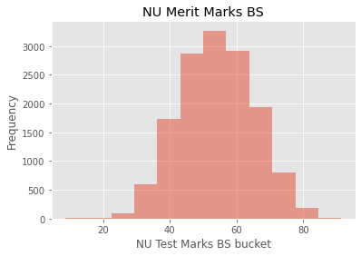

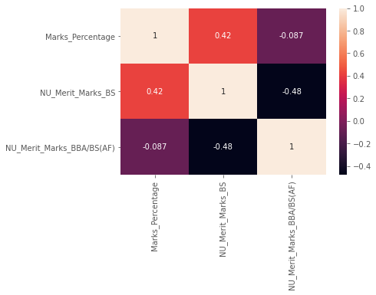

* If the student gets 85 to 100 percent marks in Matric/O-level exams have a better chance NUCES offers admission.
* Matric/O-level marks percentage is correlation NU Test Marks in BS is **0.49**
* Matric/O-level marks percentage is correlation NU Test Marks in BBA/BS(AF) **0.36**
* Matric/O-level marks percentage are correlation NU Merit Marks in BS is **0.42**
* Matric/O-level Obtained marks are correlation NU Test Marks in BBA/BS(AF) **0.2**
* Matric/O-level Obtained marks are correlation NU Test Marks in BS **0.35**
* Matric/O-level Obtained marks are correlation NU Merit Marks in BS **0.33**

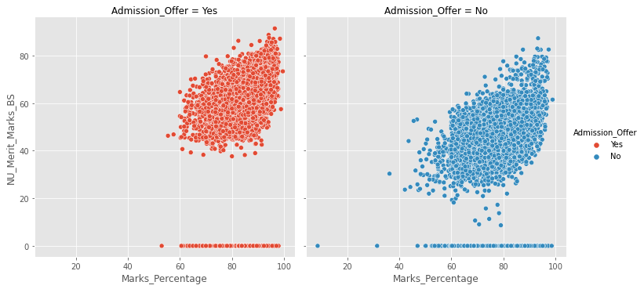

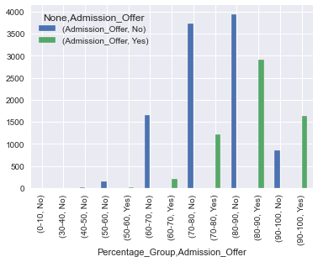

* Student get the matric marks 90-100 percent there is a better chance to get admission Offers NUCES

Question 2.

Do the students performing good in FSC/A-level exam have a better chance of getting admission in NUCES?

* FSC/A-level obtained marks are greater than FSC/A-level total marks.

Let FSC/A-level obtained marks are group marks i.e (450 marks group into 400-500)

* student Matric obtained marks and intermediate obtained marks are same.
* Yes
* If the student gets 980 to 1100 marks in FSC/A-level obtained marks have a better chance NUCES offers admission.

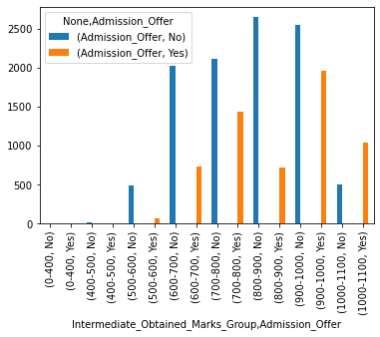

* Intermediate obtained marks is correlated NU Test Marks and NU Merit Marks

**Correlation**

|  | Intermediate Obtained Marks |
| --- | --- |
| NU Test Marks BBA | 0.20 |
| NU Test Marks BS | 0.35 |
| NU Merit Marks BBA/BS(AF) | 0.40 |
| NU Merit Marks BS | 0.48 |
|  |  |

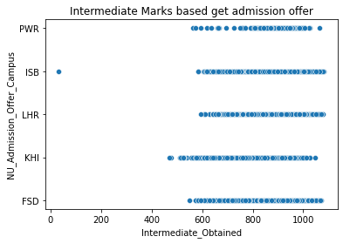

* The Intermediate obtained marks data show that NU admission Offer

**Intermediate Student Marks NU Admission Offers**

| 1000-1100 | 20.6% |
| --- | --- |
| 900-1000 | 33.9% |
| 800-900 | 11.3% |
| 700-800 | 23.7% |
| 600-700 | 9.69% |
| 500-600 | 0.7% |

* If the student marks between 1000 to 1100 and pass the NU Test. There is a better chance NU Offer admission.

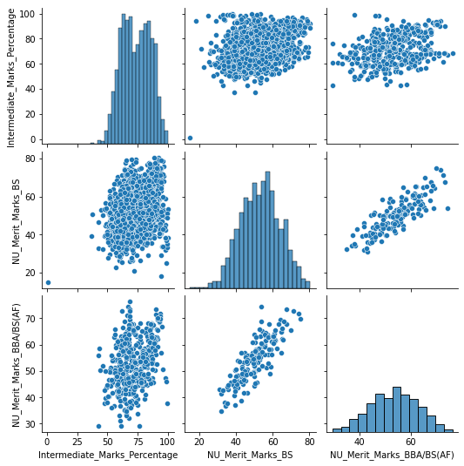

Question 3.

Do the students who could not get the first preference of their choice of discipline failed to

join NUCES?

* No
* because the majority of students failed to join NUCES
  + Students was not get the first preference discipline majority of students to join BSCS discipline.

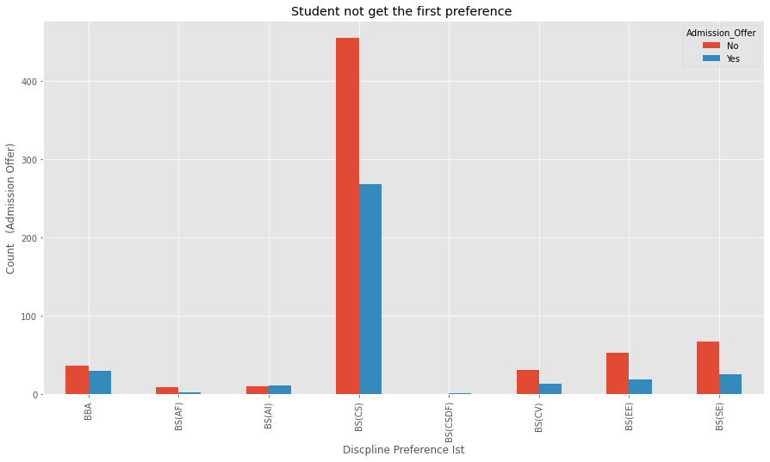

* The bar chat shows the student's first preference discipline-wise.
* Most of the students desire to join the CS discipline but they did not get admission.
* Students to desire to get first preference but they did not get first preference. Most students join the CS discipline.

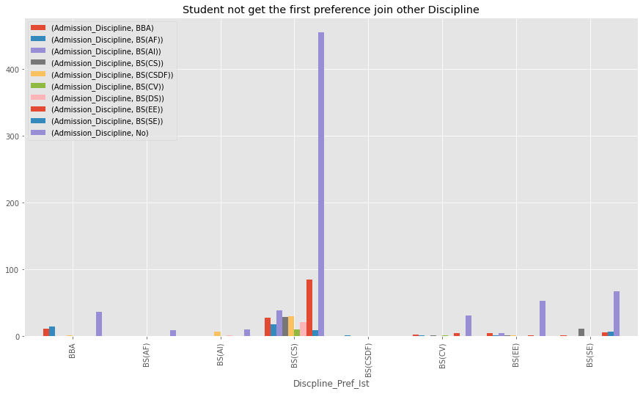

* The below graph shows that variance of discipline:

Student was not get the first preference majority student join BSCS discipline.

Discipline 1st Preference Admission other Discipline Percentage

| BBA | BBA | 16.4% |
| --- | --- | --- |
| BBA | BS(AI) | 4.5% |
| BBA | BS(CS) | 3.8% |
| BBA | BS(EE) | 6.9% |
| BBA | BS(SE) | 2.12% |
| BS(AF) | BBA | 22.3% |
| BS(AF) | BS(AF) | 8.3% |
| BS(AF) | BS(AI) | 4.5% |
| BS(AF) | BS(CS) | 2.4% |
| BS(AF) | BS(CSDF) | 100% |
| BS(CS) | BS(AF) | 8.3% |
| BS(CS) | BS(AI) | 4.5% |
| BS(CS) | BS(CS) | 4.0% |
| BS(CS) | BS(CV) | 4.4% |
| BSCS() | BS(EE) | 2.7% |
| BS(CS) | BS(SE) | 11.7% |
| BS(DS) | BS(AI) | 9.0% |

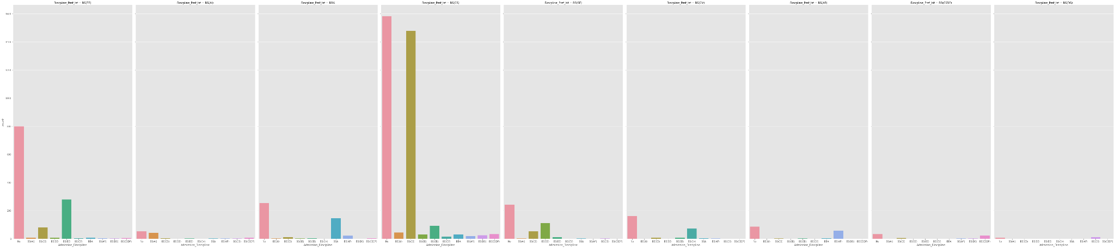

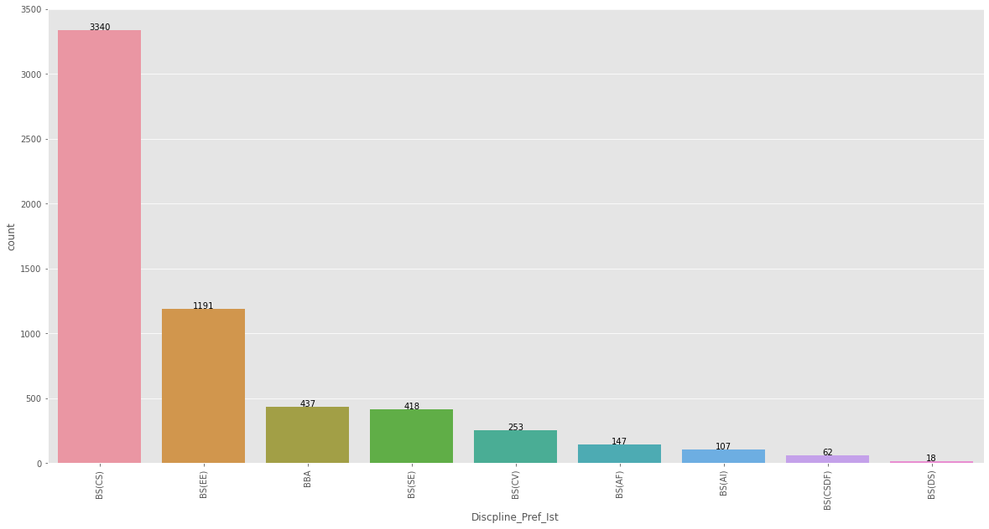

Question 4.

Students who have passed the NTS exam instead of the NU test have a better chance of

joining NUCES?

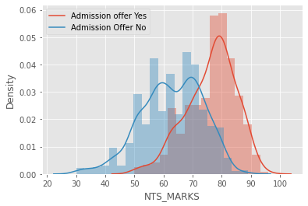

* Yes if the student get 85-100 NTS marks there is a chance to get admission NUCES.
* Student get the 85-100 NTS marks student choice to admission discipline.Show in graph.

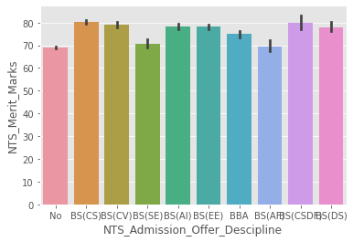

Question 5.

Which BS program is a popular choice for admission (campus wise analysis required)?

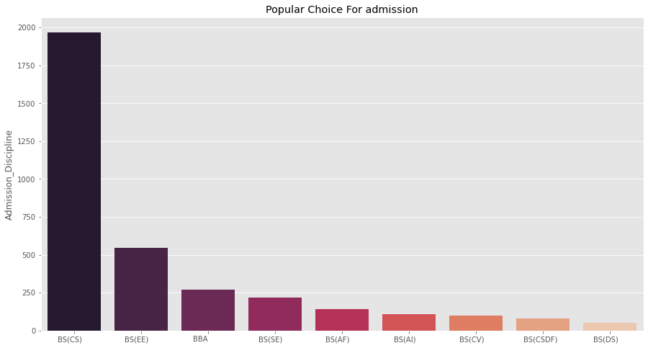

* BS(CS) Program is a popular choice for admission every campus.
* Second BS(EE) is a popular choice for admission every campus.

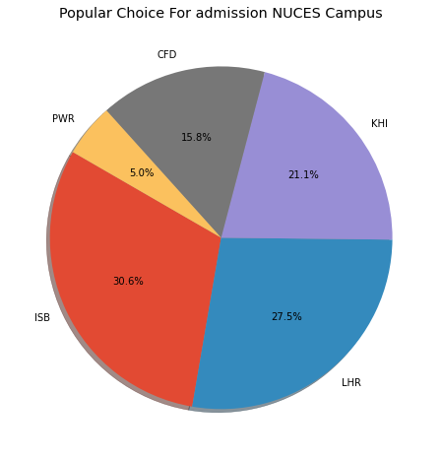

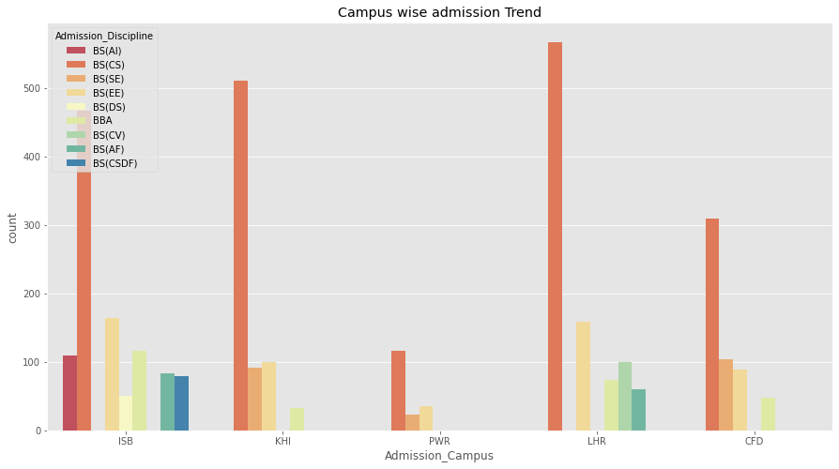

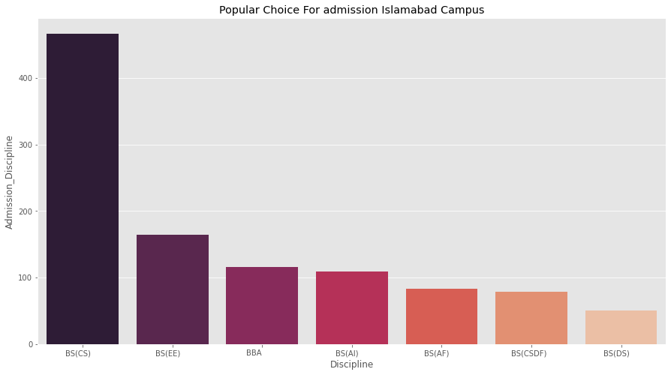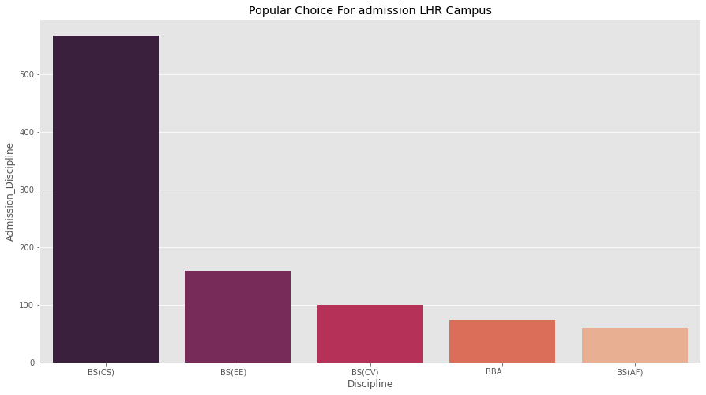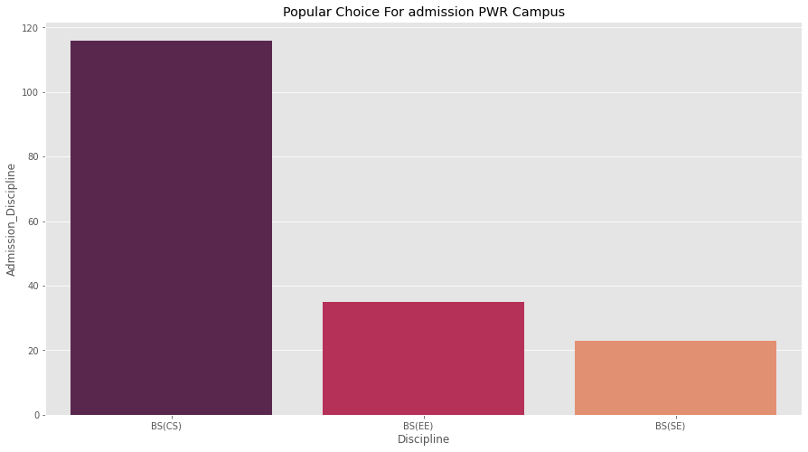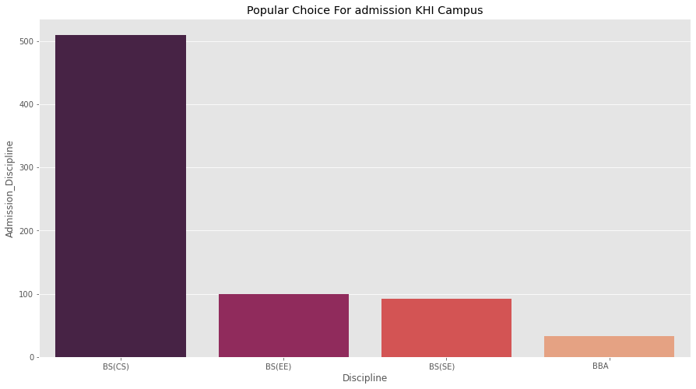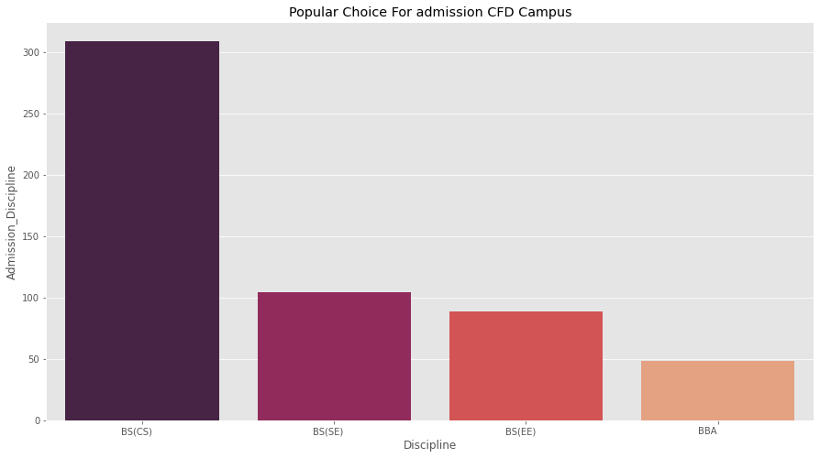

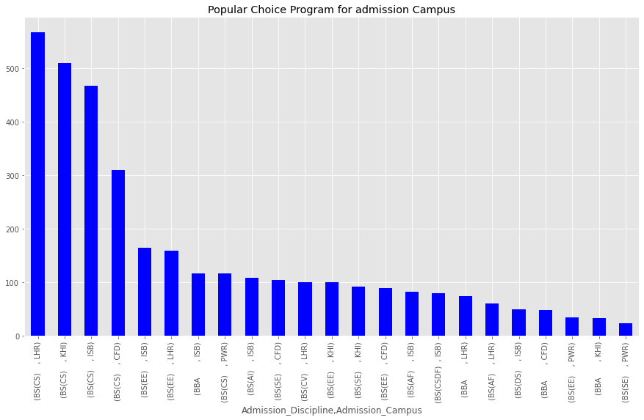

Question 6. Is there any correlation between the Matric/O-level/F.Sc./A-Level and the NU test score?(Students with the NTS test score can be ignored here)

Yes,

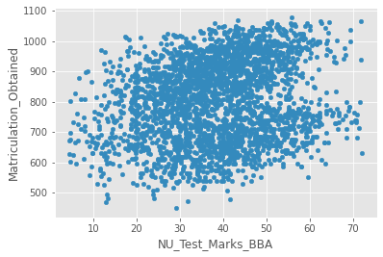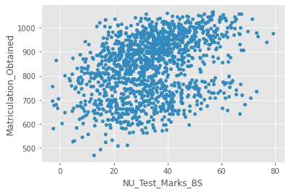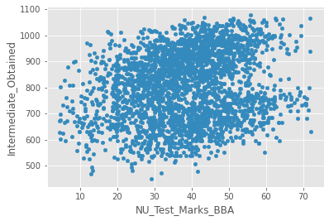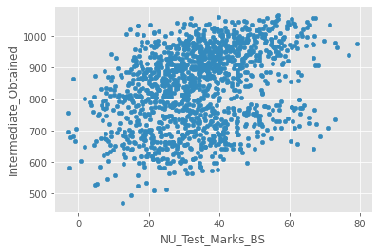

correlation

|  | Intermediate |
| --- | --- |
| Matric | 1 |
| NU Test Marks BBA | 0.19 |
| NU Test Marks BS | 0.34 |

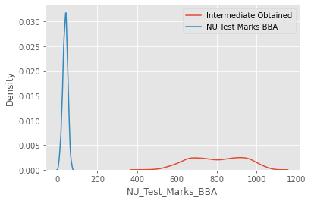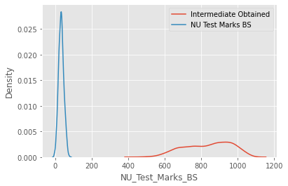

Question 7. Which Intermediate Boards were successful in getting admission in NU?

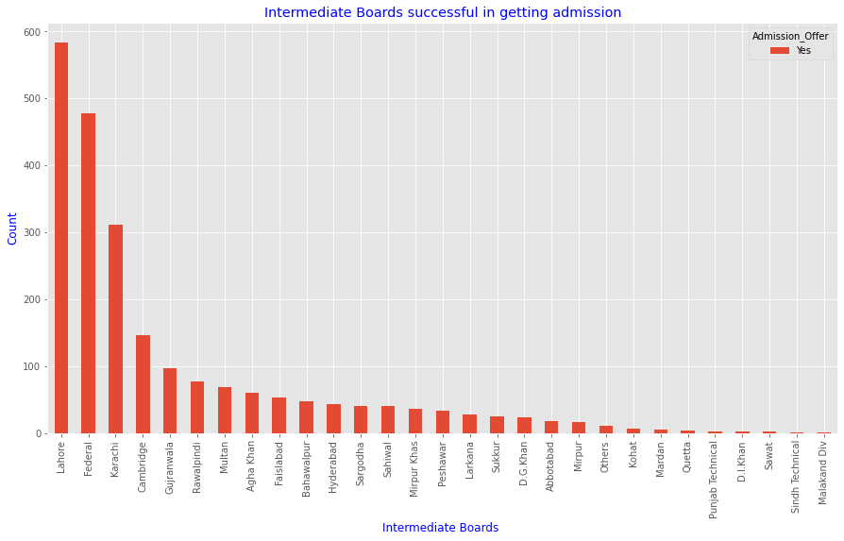

Question 8. Which region’s Intermediate board performed best in the NU test? You can categorize the boards into five regions (4 provinces + Federal). Is there any correlation between the Board and the performance in the NU test?

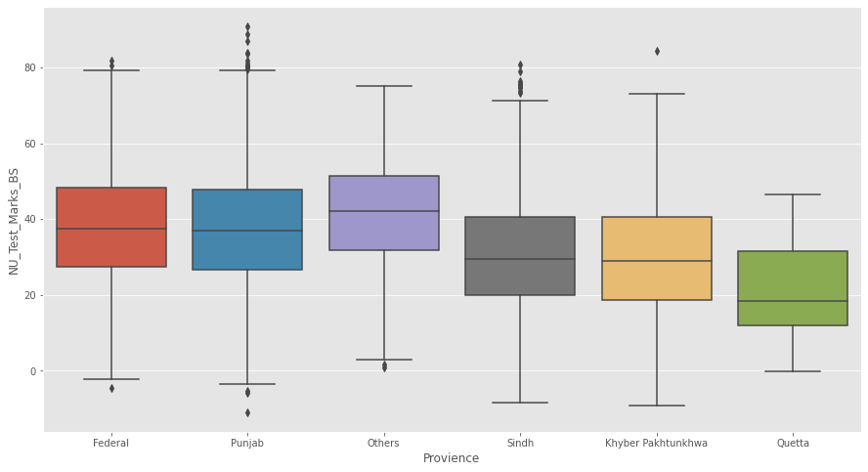

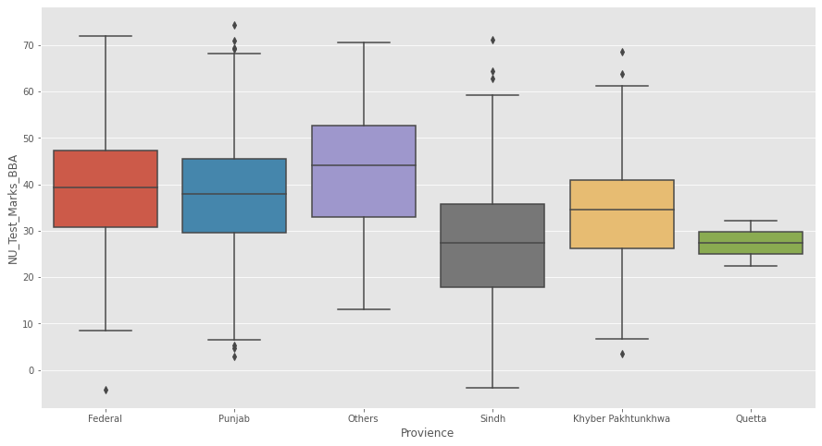

Question 9. It was commonly believed that NU gives admission to students with at least 70% marks in F.Sc. Do you concur with this hypothesis based on the given data?

No,

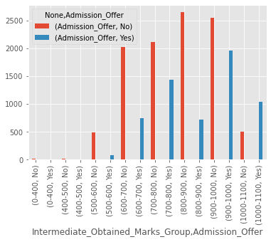

It is not true because the majority of students get greater than 70% but they did not get admission in NUCES.

Question 10. Administration was told that all applicants given admission in NU had scored more than 50% in NU test. Administration is skeptical about this claim. Can you accept or reject it based on the given data?

No,

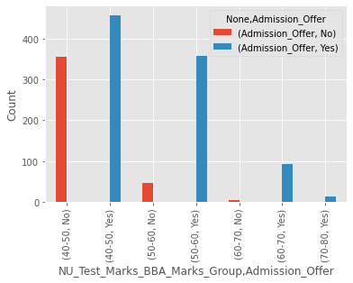

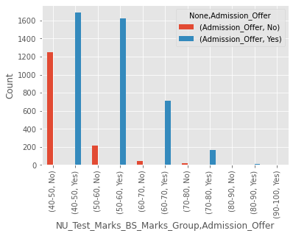

Because many students 40-50 range marks get admission in NUCES.